O&R, ch. 5: Uncertainty and International Financial Markets (p. 270)

Trade risk internationally
- Banks in Estonia owned by foreign banks
- Estonian stock and corporate bonds held by foreigners
- Estonians buying German government bonds
- Tallink insuring its ships at a Swiss insurance company

Trade risks
- Some buys insurance and reduces exposure to risks, others sell insurance and takes on risks
- Some sells risks, others buy risks

Risk adverse individuals → possibly large utility gains from buying insurance (trading of risks)
- Buy explicit insurance (private, public)
- Buy implicit insurance (e.g. match currency flows, diversify exports)

Risk loving individuals → possibly large utility gains from selling insurance (trading of risks)
Here: representative agent in economy → no trades of risks (or anything else) between identical agents in economy! → representative agent / “country” trades risks with abroad!

E.g. risk trading and the current account
Assume international insurance bought (e.g. against a bad domestic harvest)
If bad shock
⇒ insurance payout received
→ capital inflow (financial account < 0)
⇒ current account < 0

Some questions
- Which price to pay for insurance?
- Full or only partial insurance?
- Effects on current account balance?

“Sophisticated international financial markets … force us to rethink the channels through which macroeconomic shocks impinge on the world economy” (O&R, p. 270)
A primer on risk preferences

- Question: Do you prefer 5 apples with certainty or gamble giving 0 apple (if s = 1) or 10 apples (if s = 2) each with 50% probability?
- Certainty → consumption C = 5
- Fifty-fifty gamble → consumption 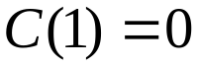 with prob. 0.5 and C(2) = 10 with prob. 0.5; Expected consumption = E[C] = 0.5·0 + 0.5·10 = 5

Assume individual is risk averse (strictly concave utility function)

u(C)

0 5 10 C(s)
How does your utility function look like if you are a) risk averse, b) risk neutral, c) risk loving?

Possible for an individual to be risk loving, risk neutral and risk adverse at the same time?
→
Which gambles will you take? [think € = consumption]
- 0 € or 10 € each with 50% probability vs. 5 € for sure
- 0 € or 1,000 € each with 50% probability vs. 500 € for sure
- 0 € or 1,000,000 € each with 50% probability vs. 500,000 € for sure

5.1 Trade across random states of nature: The small-country case (p. 271)

- Small country
- Endowment economy
- 2 periods
- 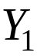 certain
- 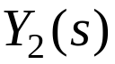 where state 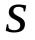 realised with prob. 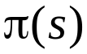, 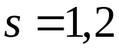 [← often two states of nature]

Index s is state of nature!

E.g.
s = 1 → harvest next year good
s = 2 → harvest next year bad

Individual chooses:

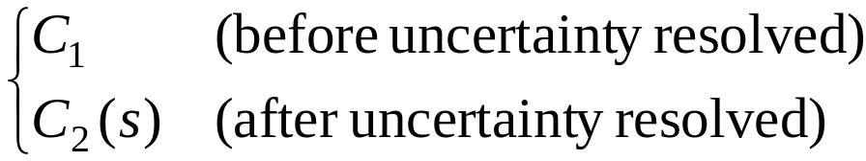

Contingent consumption (contingent on whether s = 1 or s = 2)
Expected discounted lifetime utility:

⇒
⇒

And now, ladies and gentlemen:
- The market for…
…contingent claims / assets → assets where payoff is function of “state of nature” 

Arrow-Debreu security (AD-security)
- Owner / buyer receives 1 unit 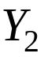 if occurs in period 2
- Seller pays 1 unit if occurs in period 2

Compare with non-contingent / riskless bond → owner always receives 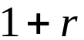 units in period 2

NB: Combine (create portfolio) of AD-securities to create “complex” / composite financial products

E.g.:
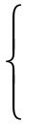
() AD-securities with payout if s = 1
() AD-securities with payout if s = 2
~ [← equivalent to]
1 riskless bond

NB: If both AD-securities traded in economy with only two outcomes of uncertainty → no “need” for separate bond in portfolio as already “complete markets”

Complete asset markets → trade AD-securities for every future state

Assume: Complete international asset markets
- NB: international investors assumed to be willing to buy/sell AD-assets depending on every possible shock-realisation in our country

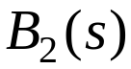 = net purchase of state s AD-security in period 1
> 0 → “long position” (and so get money in period 2 if s in period 2)
< 0 → “short position” (and so pay money in period 2 if s in period 2)

Price of AD-security with payout if s (in terms of period 1 good) = 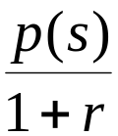

Given exogenously by world market!

Intertemporal budget constraint

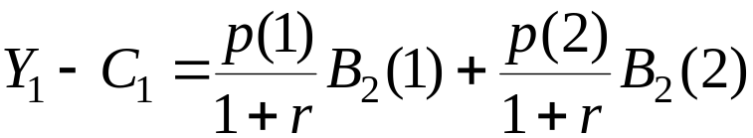 (Period 1)

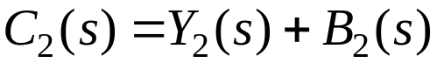, (Period 2)

Combine (find 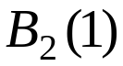 and 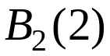 from period 2 constraints and insert in period 1 constraint):

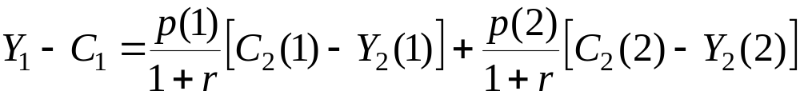
⇒
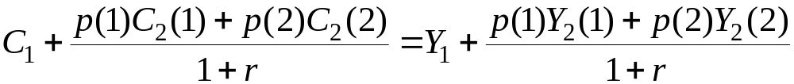

Interpretation
- RHS: Value of household’s resources (discounted to period 1)
- LHS: Household consumption (discounted to period 1)
Trade in AD-securities → stochastic resources available in period 2 can be sold and thus be converted to a certain, deterministic resource as of period 1
- “Possible to consume in period 1 the uncertain endowments of period 2”
←
“The magic of financial markets” ☺

Individual’s problem

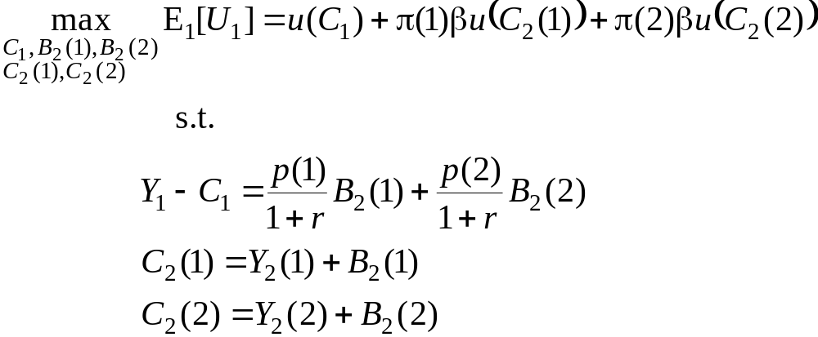

Insert 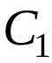, 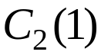, 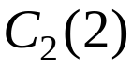 from budget constraints:

FOC (w.r.t. 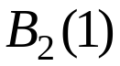 and ):

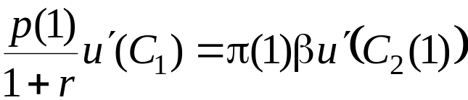 ⇒ 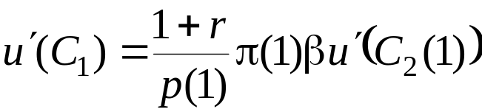

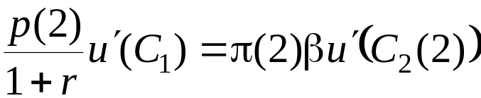 ⇒ 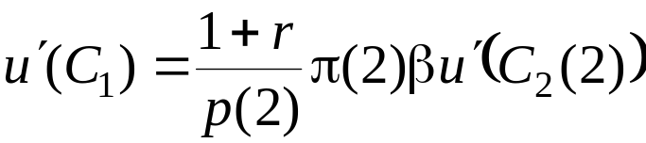

Euler equations → optimal allocation of resources across periods and states of nature
- NB: Here: two equations in three unknowns [← not one equation in two unknowns]

- LHS: Utility in period 1 from consuming one extra AD-security for given state
- RHS: Expected discounted utility in period 2 from having one extra unit consumption in that given state
- If < buy more AD-security, if > buy less AD-security (as 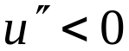)
Divide first Euler equation by second Euler equation:

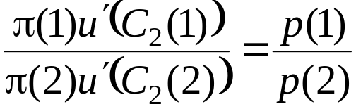 (#)

Expected MRS of state s = 2 consumption for state s = 1 consumption

Def.: Full insurance → 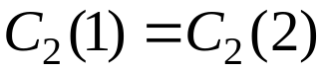 ⇒ 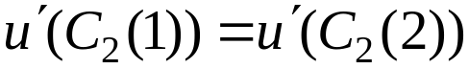

When choose full insurance? → insert into (#) ⇒ 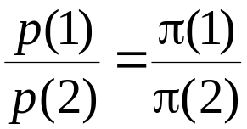

← AD-security prices actuarially fair

Actuarially fair pricing ⇒ relative price of AD security reflects relative riskiness
- High risk ~ high price to ensure against risk!
Full insurance requires that AD-security prices are actuarially fair
- If insurance prices are not actuarially fair → individuals retain / take on some risk

Important (implicit) result
- If actuarially fair pricing of risk → all risks “traded away” → consumption in period 2 constant across all states ⇒ no co-variation between income and consumption
  - If not actuarially fair pricing → consumption may co-vary with income (depending on degree of risk-aversion) [discussed later]

NB: Extent of covariation may be used for an empirical analysis of whether insurance / financial markets are “efficient” / well-functioning (cf. above)
- See testing in applied study by Demyanyk et al. (2008)

Use Euler equations to price “composite securities”, assuming all arbitrage possibilities exhausted!

E.g. Riskless bond
Buy 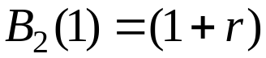 and 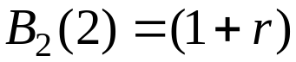 → yields 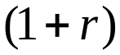 in period 2 for sure! → equivalent to bond!

Arbitrage
→
Price of composite portfolio “mimicking bond” = price of bond

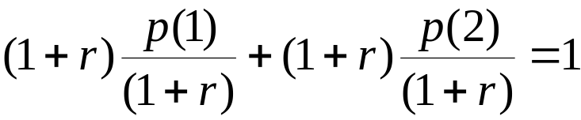
⇒
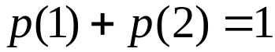

The condition ← arbitrage condition!

Arbitrage condition when ∫ states: 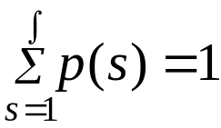, where ∫ is “script S”
NB:

Actuarial fairness + arbitrage ⇒ very “tight” conditions on prices of AD-securities…

Actuarial fairness:

Arbitrage:

(Probability distribution with two outcomes: 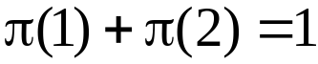)

Actuarial fairness + arbitrage ⇒ 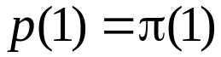, 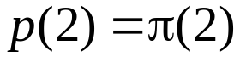
Will the insurance company become rich ☺?

Find insurer’s expected discounted profit 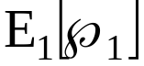 when it sells and and the market (“objective”) discount factor 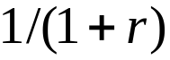 is used for discounting

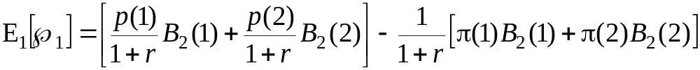

If actuarially fair prices (and arbitrage) → ,
⇒
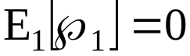!

Result → when actuarially fair prices, a risk-neutral agent / insurer would be indifferent between selling insurance and doing nothing

Risk aversion (p. 276)

Individual’s optimal state-contingent consumption choice (from Euler equations):

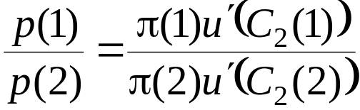 (#)

Find how consumption across states depend on AD-prices (“insurance premiums”) → find how 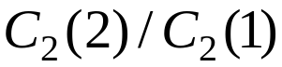 depends on 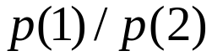

Take logs:

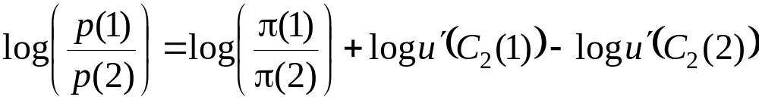

Total differentiation (for variables 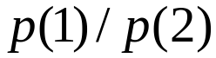, 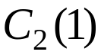 and 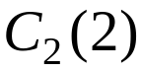; 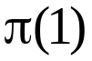 and 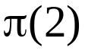 constant):

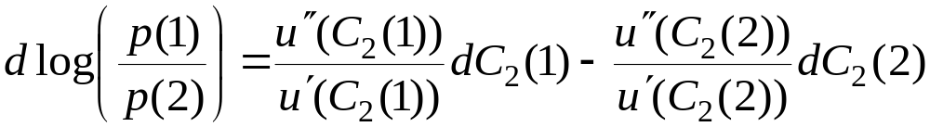
Multiply and divide by 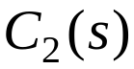 in the terms on the RHS, and use that 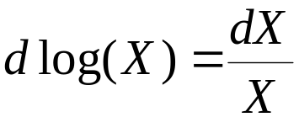:

(##)

Label: 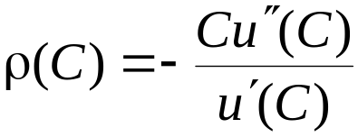 = Arrow Pratt coefficient of relative risk aversion

- 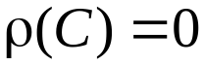 ⇒ 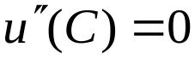 ⇒ 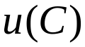 is linear → risk-neutrality!
- 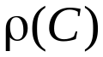 large ⇒ has “lots of curvature” → risk-averse!

Simplify (##) by inserting notation for Arrow Pratt coefficient of relative risk aversion:

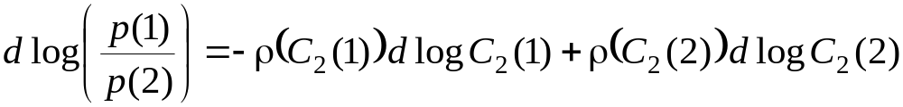 (###)

Consider CRRA = Constant coefficient of Relative Risk Aversion
- NB: CRRA is sometimes (but not in this book) abbreviation for Coefficient of Relative Risk Aversion

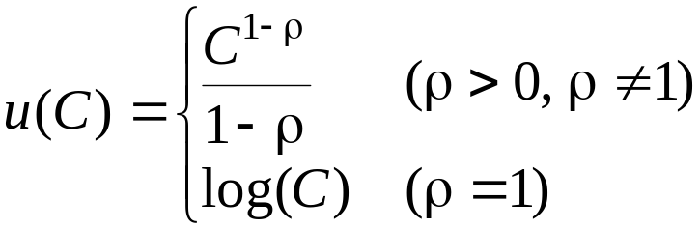

Calculate = 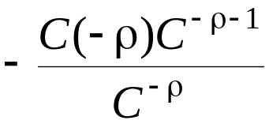 = 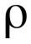 = constant ☺

If CRRA, i.e. constant (coefficient of) relative risk aversion = , then (###) becomes:

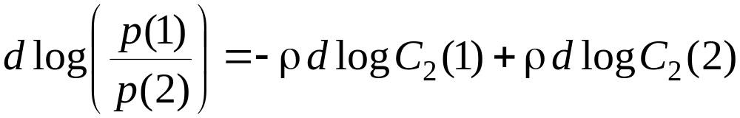
⇒
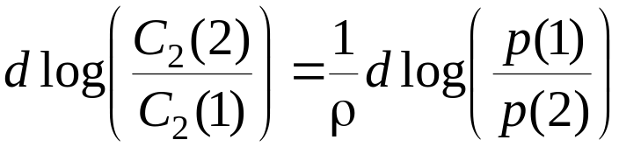
- Link (1/ρ) between change in relative price of two AD-securities and change in relative consumption in two states
- Intuition: If 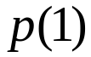 increases relative to 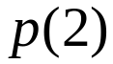 (i.e. insurance against 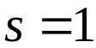 events relatively more expensive) ⇒ buy less insurance against events ⇒ consumption if event relatively smaller

- If very small → large impact on consumption in two states of a change in relative insurance prices
- Intuition: If very small → “almost risk neutral” → differences in consumption over states not so important. (E.g.: when s = 1 insurance price ↑ ⇒ scale back s = 1 insurance a lot ⇒ 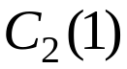 relative to C₂(2) much smaller)

- If large → little effect on consumption if relative price changes
- Intuition: If large → very risk adverse → differences in consumption over states very unwanted. (E.g.: when s = 1 insurance price ↑ ⇒ little impact on s = 1 insurance ⇒ changes only little
Problem

When “expected utility” framework
→
Elasticity of Intertemporal Substitution 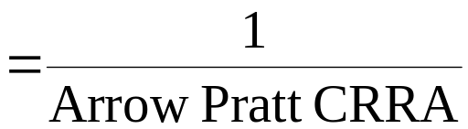

Problem: Cannot vary elasticity of intertemporal substitution without varying risk aversion within expected utility framework!

If separate elasticity of intertemporal substitution and risk aversion → leave expected utility paradigm → technically difficult!

Log utility example (p. 279)

Find solution to individual’s problem:

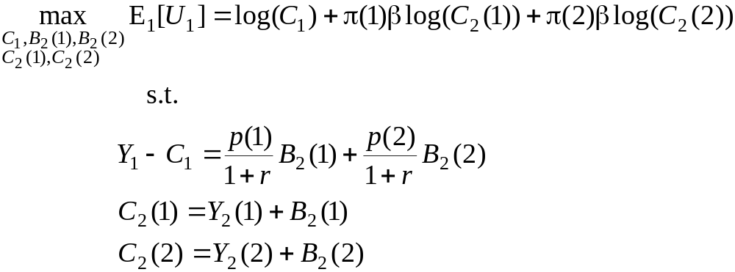
“Intertemporal budget constraint” (§)
⇒

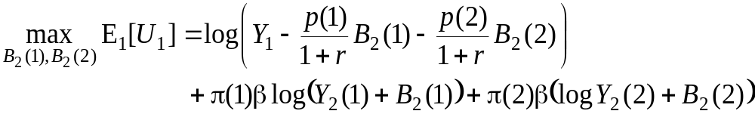

FOC:

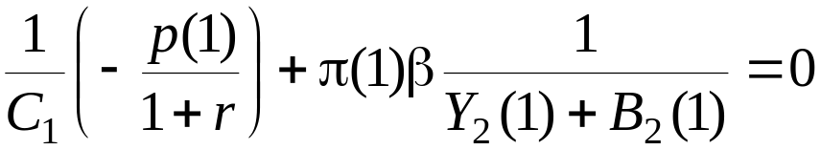

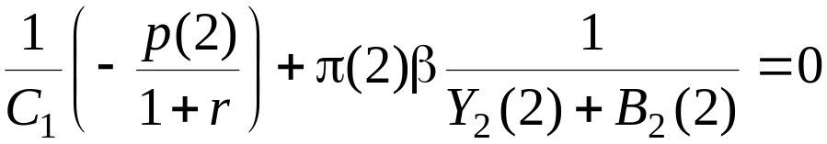

[NB: If the two FOCs are combined (by eliminating ), then the result is:
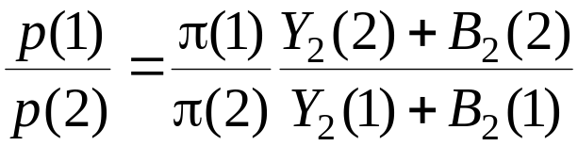; cf. (#) on slide 17.]

Rewrite the two FOCs:

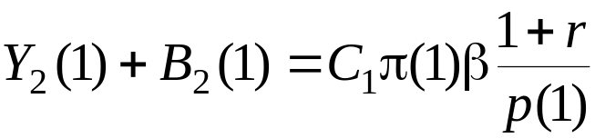

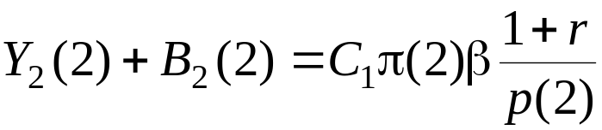
Isolate the amounts of AD-securities (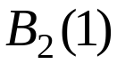 and 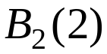) from the two equations and insert these into the intertemporal budget constraint (§) on slide #22:

Multiply into curled brackets:

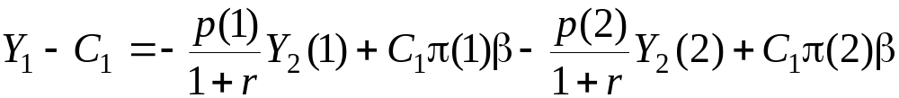

Isolate 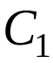:

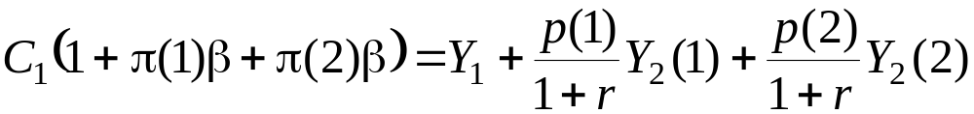
⇒
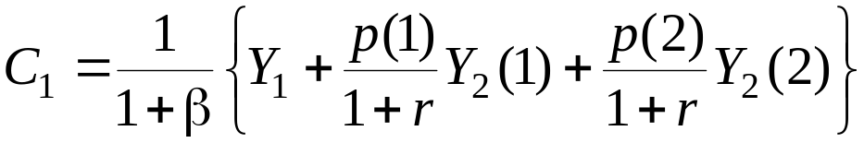

Total value of periods 1 and 2 endowments
Current account

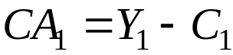
⇒
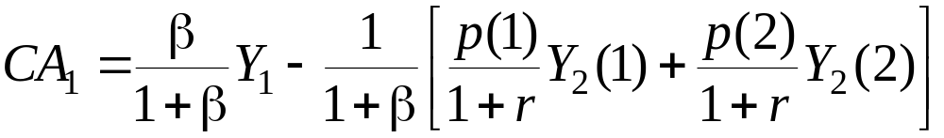

Total value of period 2 endowment

- 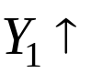 ⇒ 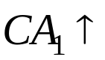 [Nice familiar result ☺!]
- Total value of 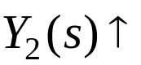 ⇒ 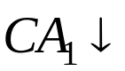 [Nice semi-familiar result ☺!]

Sentiment shifts in global financial markets → effect on the current account?
→
Consider: “sentiment shift” so p(1) ↑ and/or p(2) ↑ ⇒ ← current account balance ↓ in period 1 [← Estonia early 2000s given prospect of joining NATO and EU?]
- Uncertain future income now worth more → consume more now!
5.2 A global model (p. 285)

Until now → small open economy ⇒ prices of AD-securities given from abroad
Now → large country impacting prices of AD-securities

Find price of assets contingent on shocks /states…

Global model: Home + Foreign*

- Country-specific risk (impacting only specific country)
- Global risk (impacting both countries)

5.2.1 The CRRA case

CRRA = Constant Relative Risk Aversion, i.e. coefficient of relative risk aversion constant

∫ (script S) states, s = 1, …, ∫
Equilibrium
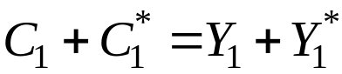
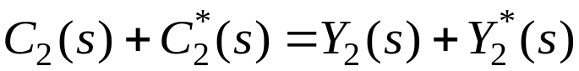, s = 1, …, ∫

NB1: Consumptions from individuals’ maximisation problem (Euler + constraints)
NB2: Walras’ law → one of equations / equilibrium conditions redundant

Def.: 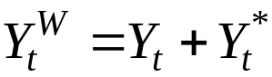, t = 1,2

Expected discounted utility if CRRA preferences:

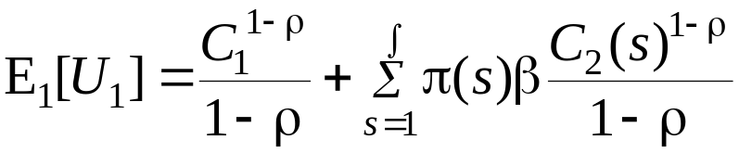

Max 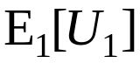 s.t. constraints! 

Individual’s problem (Home)
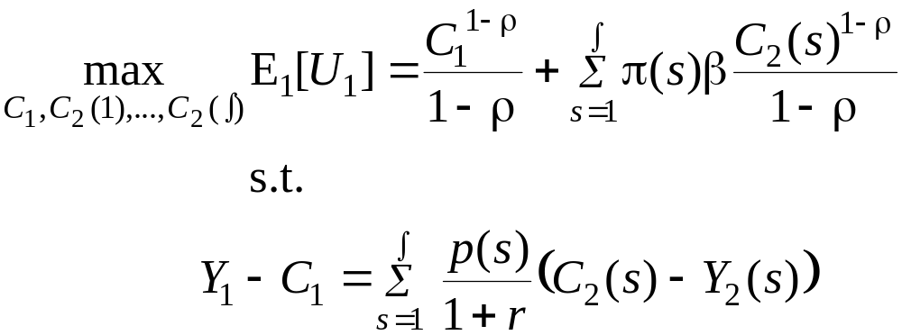

NB: Purchase of AD-securities implicit here!

⇒
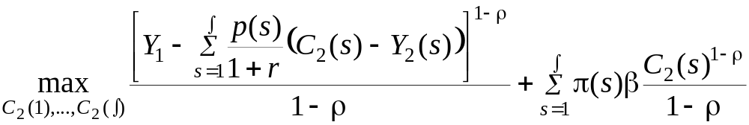

NB: not any more argument in maximisation problem

FOC: [Differentiate w.r.t. 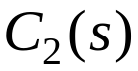, s = 1, …, ∫, and set = 0]

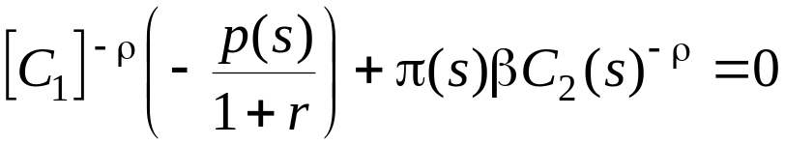, s = 1, …, ∫
⇒
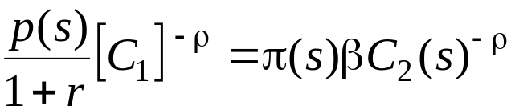, s = 1, …, ∫
⇒
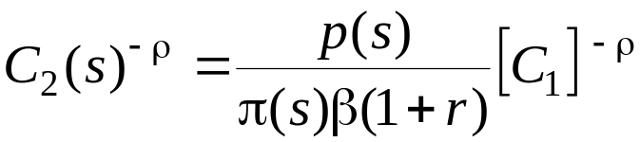
⇒
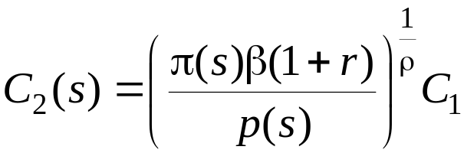, s = 1, …, ∫

Euler equations → optimising relationship between period 1 consumption and state-dependent period 2 consumption levels
- Exercise: what happens, ceteris paribus, if 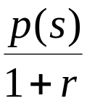 ↑ ?
Foreign (symmetry):

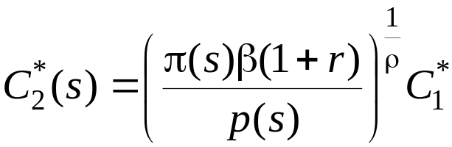, s = 1, …, ∫

Equilibrium condition [equilibrium condition for period 1 omitted, cf. Walras’ law]

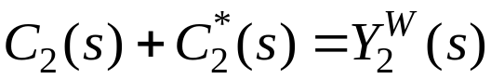, s = 1, …, ∫
⇒ [Insert consumption demands]
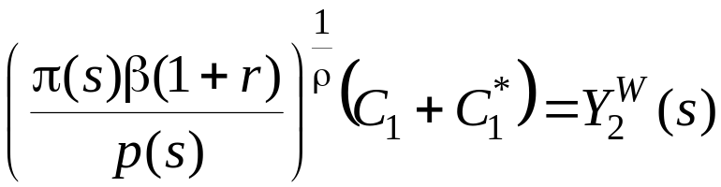, s = 1, …, ∫
⇒
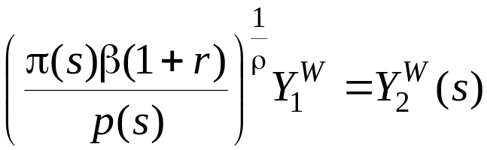, s = 1, …, ∫
⇒
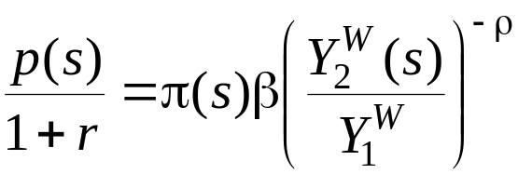, s = 1, …, ∫ (#)

Contents of pricing of AD-security s:
- If world endowment 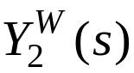 is large for a given state s ⇒ cheap to buy an AD-security that gives 1 unit of output if state s is realised
- If state s is unlikely to occur ( ↓) ⇒ cheap to buy an AD-security that gives 1 unit of output if s is realised

Consider two states, s and 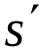 [← divide two price equations (#)]

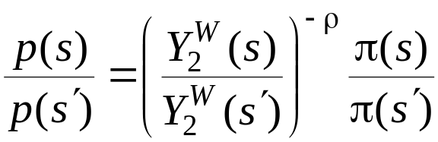 (##)

“Relative price reflects (relative) scarcity!” [← period 2 state s vs. period 2 state s’]
- Quantities available in two states
- Probabilities of two states
If no aggregate/world risks i.e. only country-specific risks

No aggregate/world risk ⇒ 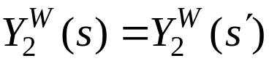

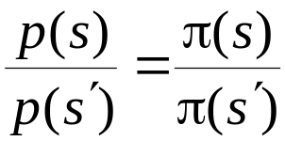 ← prices are actuarially fair!

Intuition → no need to adjust prices of AD-security to make consumption adapt to different output in different states (as 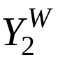 the same in the two / all states of nature)

Find real interest rate r (given arbitrage and actuarial fairness, slide #15)

⇒
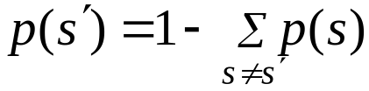
⇒
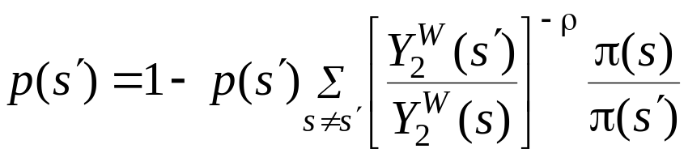 [from (##) on slide #31]

Solve for 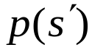 and insert into # (slide #31) to get:

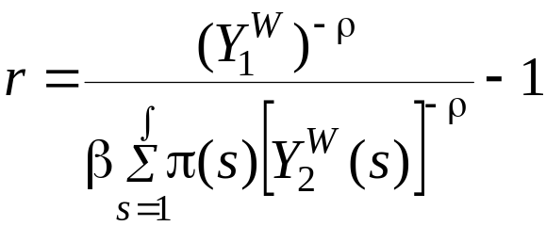

Intuition:
- If period 1 world endowment large → “everybody wants to save” → interest rate low
- If probability-weighted and discounted period 2 world endowment large → “everybody wants to borrow” → interest rate high

5.2.1.2 Equilibrium Consumption Levels (p. 287)

International financial integration
⇒ [in this model]
- Reduce / remove country-specific risks
- Share aggregate / world risks

Proof 

From FOCs (Eulers):

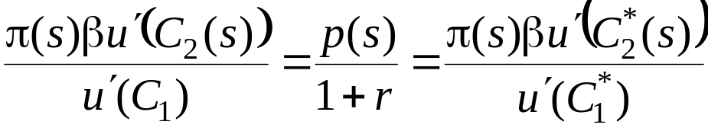 (§)

NB: When international trade in state-contingent claims (financial integration) → MRS between current and (state-contingent) future consumption the same for all countries

Find (§) also for state and divide two equations:

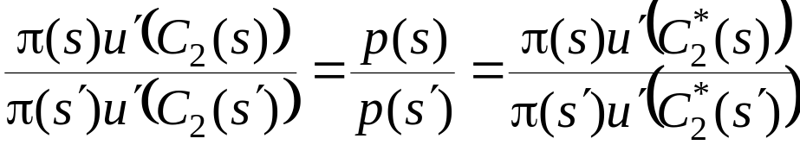

Financial integration → (probability weighted) MRS across states of nature the same for all countries

Complete markets → all gains from trade over time and across risks are exploited (as MRS the same across all periods and all states) → Pareto efficiency

NB: testable finding → consumption (and, by implication, changes in consumption) highly correlated between countries with integrated financial markets
- If e.g. 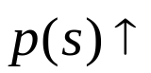 ⇒ similar / proportional changes in and 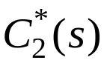

Back to CRRA

Find consumption (from FOCs / Eulers):

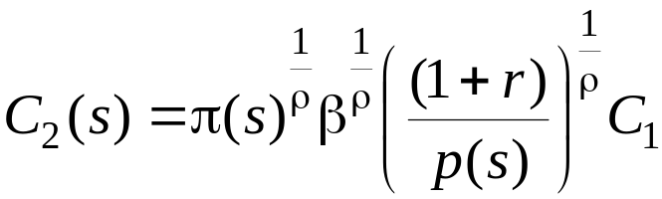 , s = 1, …, ∫

⇒ [Insert price of AD-security from (#) on slide #31]

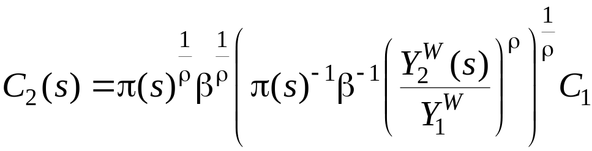

⇒ [Cancel terms]

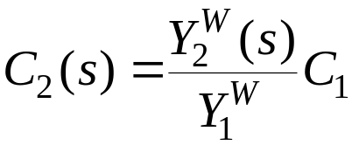

Consider other state :

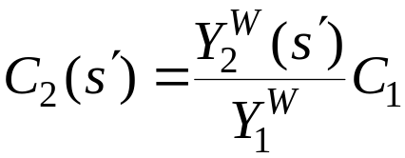

Divide expressions for state-contingent consumption:

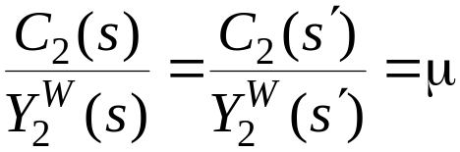

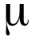 is share of world endowment consumed by home irrespective of state s
- NB: is constant across all states of nature

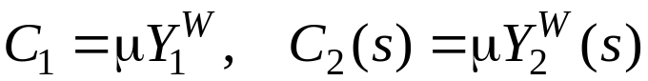 , s = 1, …, ∫ [← from bottom previous slide]
, s = 1, …, ∫

Consumption fixed share of world income in every period and every state

Interpretation
- Country’s aggregate period 2 consumption will fluctuate with world / global output shocks
- But individual country’s period 2 consumption is delinked from country’s own risks / idiosyncratic output shocks…

With CRRA, then perfect correlation between consumption in two countries (independent of correlation of endowments / production levels)
→
With more general utility functions ⇒ not perfect, but high degree of correlation between consumption in given country and world consumption

Financial integration / international trade in risks
- Delink / decouple (changes in) consumption from (changes in) country’s production ☺
- Link consumption to world production ☹

Empirics
- If international financial integration (including efficient risk trading) ⇒ theory above predicts correlation between consumption in given country and world consumption very high (and higher than correlation between output in country and world output)
- ☹ → “paradox”, cf. table p. 291

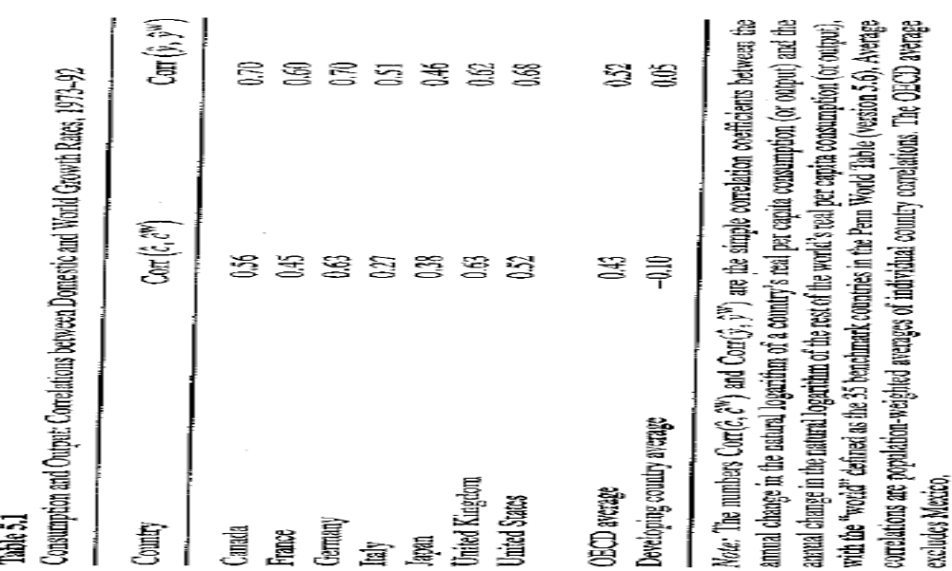
Explanations for result not confirming theory?
→
- International integration of financial markets far not perfect → information problems, transaction costs, legal barriers, …
→
- Not efficient extent of trading of risks
- Related to “Home equity bias puzzle” (pp. 304-306)
Applied studies

Leblebicioglu, Aslı (2009): “Financial integration, credit market imperfections and consumption smoothing”, Journal of Economic Dynamics and Control, vol. 33, no. 2, pp. 377-393.

Lane, Philip (2008): “EMU and Financial Integration”, IIIS Discussion Paper, no. 272.

Schuknecht, Ludger, Jürgen von Hagen & Guido Wolswijk (2011): “Government bond risk premiums in the EU revisited: the impact of the financial crisis”, European Journal of Political Economy, vol. 27, no. 1, pp. 36-43.

Fratzscher, Marcel, Christian Saborowski & Roland Straub (2009): “Monetary policy shocks and portfolio choice”, ECB Working Paper, no. 1122.

Backus, David, Espen Henriksen & Kjetil Storesletten (2008): “Taxes and the global allocation of capital”, Journal of Monetary Economics, vol. 55, no. 1, pp.48-61.

